Rack Server

🧱 What is a Rack Server?
# Source: Chatgpt (GPT-5-Mini) at [1/16/2026]
A rack server is a flat, rectangular server designed to be mounted in a server rack — a metal frame that holds multiple servers vertically, one above the other.
📌 It's a space-efficient, powerful, and scalable solution used mostly in data centers and large IT environments.

Rack Server images
# Source: Windows ScreenShots at [1/16/2026]
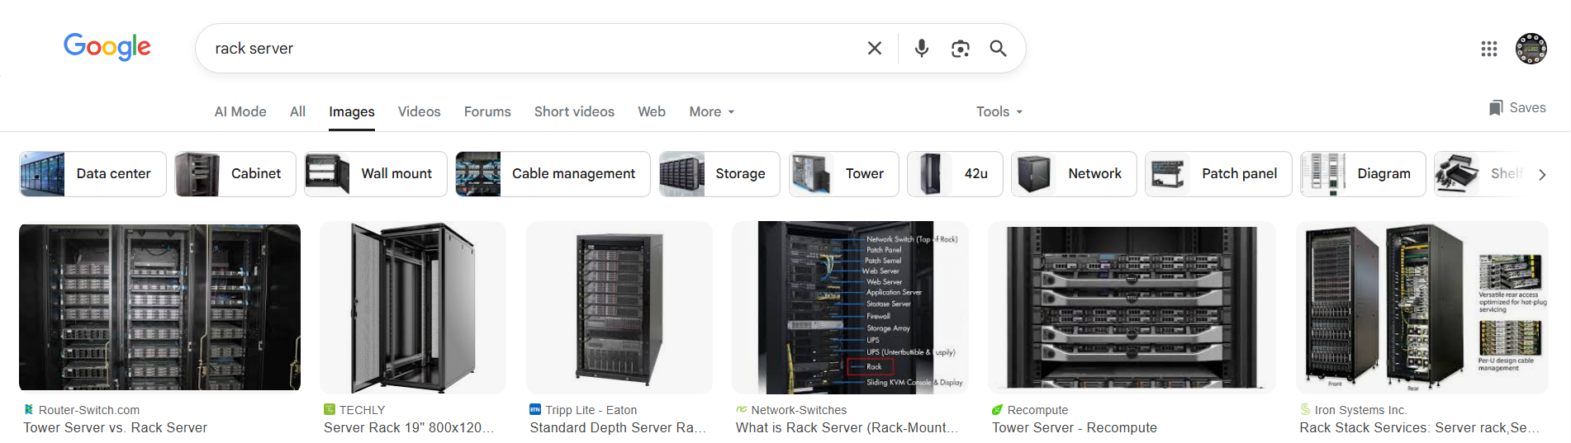

🧠 Key Characteristics
# Source: Chatgpt (GPT-5-Mini) at [1/16/2026]
Feature | Description
📏 Shape | Slim, horizontal (like a pizza box!)
🧩 Mounted in | A standardized 19-inch wide rack
📐 Size Units (U) | 1U, 2U, 4U, etc. (1U = 1.75 inches in height)
🛠️ Modular | Easy to add/remove multiple servers in a single rack
🧊 Cooling | Front-to-back airflow for better cooling in dense setups

📸 Visual Concept
# Source: Chatgpt (GPT-5-Mini) at [1/16/2026]
[ Server Rack Cabinet ]
├── [1U Rack Server - Web Server]
├── [2U Rack Server - Database]
├── [1U Rack Server - Backup]
└── [Switches / UPS / Storage Units]

✅ Advantages of Rack Servers
# Source: Chatgpt (GPT-5-Mini) at [1/16/2026]
Benefit | Why It Matters
📦 Space-efficient | You can fit dozens of servers in a single rack cabinet
⚙️ Easily replaceable | Slide-in/slide-out access — fast maintenance
🧰 Scalable | Add more servers as needs grow
🔌 Centralized power | Shared power management and network cabling
📡 Network-ready | Easily connected to switches and routers in the rack setup

❗ Common Use Cases
# Source: Chatgpt (GPT-5-Mini) at [1/16/2026]
Environment | Why Use Rack Servers?
🏢 Data Centers | Maximize space, cooling, and performance
🌐 Web Hosting Providers | Run hundreds of websites from one rack
🧪 Research Labs / HPC | Clustered computing, AI, scientific tasks
📊 Corporate Networks | File, email, virtualization servers

🖥️ Examples of Rack Server Models
# Source: Chatgpt (GPT-5-Mini) at [1/16/2026]
Model | Manufacturer | Specs Example
Dell PowerEdge R640 | Dell | Dual Xeon CPUs, up to 1.5TB RAM
HPE ProLiant DL360 Gen10 | HP Enterprise | 1U, enterprise-grade
Supermicro SuperServer | Supermicro | Affordable custom configurations
Lenovo ThinkSystem SR650 | Lenovo | Supports virtualization & storage

⚠️ Considerations
# Source: Chatgpt (GPT-5-Mini) at [1/16/2026]

Factor | Detail
Noise | Often very loud (not for home use)
Cooling | Needs climate-controlled environment
Power | Needs UPS or PDU in data center
Cost | More expensive than tower servers

✅ Summary
# Source: Chatgpt (GPT-5-Mini) at [1/16/2026]

Feature | Description
What is it? | Flat server that fits into a rack
Used by | Enterprises, hosting companies
Benefit | High density, scalable, efficient
Drawback | Loud, complex setup, not for beginners

